Отобразить(пока временно) во вью **cart name user**, чьи товары находятся в корзине (пока - **все admin**).

1.**views\front\cart.blade.php**

<thead>

<tr>

<th></th>

<th>Name</th>

<th>Price</th>

<th class="center">Remove one</th>

**<th>User</th> <!-- !!! -->**

</tr>

</thead>

2.**ShopRepository**

/**

* Create a query for Cart.

*

* @return \Illuminate\Database\Eloquent\Builder

*/

public function **fromCart**()

{

$query = $this->**model_cart**

->select('id', **'user_id'**, 'name', 'price', 'image'); **//!!!user_id**

return $query->get();

}

3.**views\front\brick-standard-cart.blade.php**

...

**<td>**

**<span>{{$cart->user->name}}</span>**

**</td>**

</tr>

@endforeach

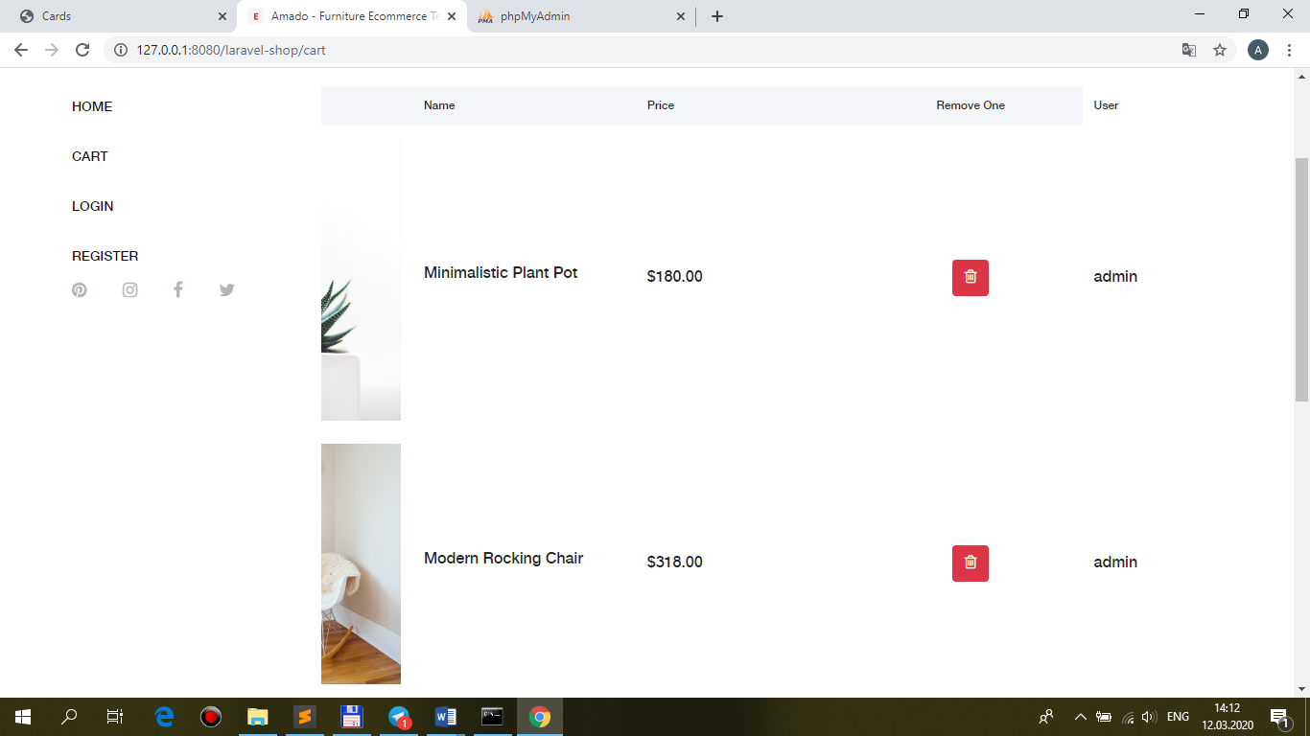

Реализация метода **index ShopController** через **trait**:

1.**app\Http\Controllers\Front\ShopController.php**

use App\ {

…

**Http\Controllers\Traits\Indexable**

};

class **ShopController** extends Controller

{

**use Indexable;**

/**

* Create a new controller instance.

*

* @return void

*/

public function **__construct(ShopRepository $repository)**

{

//$this->middleware('auth');

**$this->repository = $repository;**

**$this->namespace = 'front';**

}

/**

* Show the application home-page.

*

* @return \Illuminate\Contracts\Support\Renderable

*/

**/\***

public function index(Request $request, ShopRepository $repository)

{

…

}

**\*/**

2.**app\Http\Controllers\Traits\Indexable.php**

**trait Indexable**

{

/**

* The Repository instance.

*

* @var \App\Repositories\ShopRepository

* @var \App\Repositories\AdminRepository

*/

**protected $repository;** //ShopRepository or AdminRepository

/**

* The namespace

*

* @var string

*/

**protected $namespace;** //front or back

/**

* Show the application home-page.

*

* @return \Illuminate\Contracts\Support\Renderable

*/

public function **index**(Request $request)

{

$products = **$this->repository**->funcSelect($request);

// Ajax response

if ($request->ajax()) {

return response()->json([

'table' => view(**$this->namespace . ".brick-standard"**, ['products' => $products])->render(),

]);

}

return view(**$this->namespace . '.index'**, ['products' => $products]);

}